LGBT Ally Training:
Learn & Grow By Talking
Miscellaneous Materials
Large Print Edition

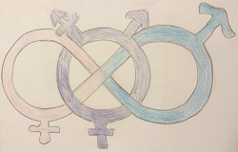

Developed by members of
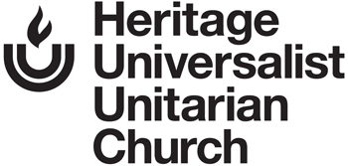
in partnership with

Cincinnati, Ohio.
October 10, 2019
LGBT Ally Training: Learn & Grow By Talking – Miscellaneous Materials

LGBT Ally Training: Learn & Grow By Talking was developed by Russ Araujo, Angi Eury, Rai Eury, Shannon M., and other members of Heritage Universalist Unitarian Church, 2710 Newtown Road, Cincinnati, Ohio 45244. It is offered under the Creative Commons Attribution-ShareAlike 4.0 International license, found at https://creativecommons.org/licenses/by-sa/4.0/.
Early guidance in curriculum development and possible content was provided by Melissa Meyer (mmeyer@lys.org or 513-487-7115), Director of Safe and Supported (www.safeandsupported.org), which is dedicated to ending LGBT youth homelessness in Hamilton County, Ohio. Safe and Supported is a project of Lighthouse Youth and Family Services.
The essay On Being Misgendered is by Kit Malone and is used with Kit’s permission.
The Gender Neutral Restroom sign comes from the Unitarian Universalist Association (http://www.uua.org/lgbtq/welcoming/ways/bathrooms). The webpage encourages downloading and using the sign.

At present (October 10, 2019), this curriculum document can be downloaded from:
http://huuc.net/lgbt-ally-training-curriculum/
Questions, comments and feedback can be directed to LGBTAllyCurriculum@huuc.net

Table of Contents

List of Miscellaneous Materials, with Links 5
Breakout Room A 7
Breakout Room B 8
Breakout Room C 9
Breakout Room D 10
Breakout Room E 11
Changing Hearts and Minds (and Laws): More Thoughts 12
Facilitator Feedback Form to the Curriculum Developers 16
Flyer 21
Gender Neutral Restroom 22
Holiday Experiences of LGBT+ People 23
Large Group Room 26
LGBT Ally Workshop Here 27
On Being Misgendered 28
Participant Feedback Form 30
Privilege Awareness Exercise 34
Privilege Response Card: Usually True for Me 36
Privilege Response Card: Often True for Me 37
Privilege Response Card: Occasionally True for Me 38
Privilege Response Card: Rarely True for Me 39
Quiet Room 40
Values Clarification Exercise 41
Values Response Card: I Agree a Lot 43
Values Response Card: I Agree a Little 44
Values Response Card: I Disagree a Little 45
Values Response Card: I Disagree a Lot 46
List of Miscellaneous Materials, with Links

Breakout Room A (sign)
Breakout Room B (sign)
Breakout Room C (sign)
Breakout Room D (sign)
Breakout Room E (sign)
Changing Hearts and Minds (and Laws): More Thoughts
Facilitator Feedback Form to the Curriculum Developers
Flyer
Gender Neutral Restroom (sign)
Holiday Experiences of LGBT+ People (reading)
Large Group Room (sign)
LGBT Ally Workshop Here (sign)
On Being Misgendered
Participant Feedback Form
Privilege Awareness Exercise
Privilege Response Card: Usually True for Me
Privilege Response Card: Often True for Me
Privilege Response Card: Occasionally True for Me
Privilege Response Card: Rarely True for Me
Quiet Room (sign)
Values Clarification Exercise
Values Response Card: I Agree a Lot
Values Response Card: I Agree a Little
Values Response Card: I Disagree a Little
Values Response Card: I Disagree a Lot

Breakout Room A

Breakout Room A

Breakout Room B

Breakout Room B

Breakout Room C

Breakout Room C

Breakout Room D

Breakout Room D

Breakout Room E

Breakout Room E

Changing Hearts and Minds (and Laws): More Thoughts

Introducing Anti-LGBT+ People Safely to Differing Viewpoints
When you do not have a safe way to introduce someone who is anti-LGBT+ to a community member, there are other ways to bring up differing viewpoints. Social media, if used correctly, is one way. There are thousands of stories circulating of positive actions of LGBT+ community members. Share a post on your own wall, being careful to share from the original source and not sharing off a friend's page. YouTube is a great resource as well. Again, there are thousands of stories to share. Many people make their own YouTube channel to share their stories. You can share these generally on your own page as a way to start a conversation. You can also bring them up when having a conversation with someone in a nonthreatening way. Just a simple, "Oh, hey, I saw a really cool video to share with you!"
Movies are another way to reach out. There are movies with LGBT+ story lines, and there are other movies that have LGBT+ characters just as supporting cast, just as in real life. Offer to take an acquaintance to see a movie that has a positive LGBT+ story line, or a positive, non-stereotypical character. Afterwards, strike up a friendly conversation, bringing up the positive contributions from the character or story line. Just remember, do not make parallels to friends who aren't out publicly to make your point.
Books, especially biographies, can be another resource. Stories that send positive messages on a personal level always leave a greater impact in a safe manner. Again, be sure to not make parallels to people who are not publicly out.
Changing Public Opinion
Everyone has opinions and these opinions are influenced by many factors. For example, social media has prompted the spread of opinions of all kinds in a rapid manner. In recent years, the fight for marriage equality, the fight for trans rights, etc. have pushed the LGBT+ community to the center of the public eye, and has caused much debate and polarization. For those on the side against equal rights, most often opinions have been formed without the benefit of interactions with the LGBT+ community. Myths and stereotypes are passed along without any real life interactions with community members to dispel harmful ideas. Getting to know people in the community who are LGBT+ can help destroy these myths and stereotypes. People need the chance to see that different family structures do provide positive role models for all areas of life. Meeting and talking with community members who are LGBT+ in a safe and nonthreatening environment can often sway people's opinions to the more positive side. Obviously, outing someone and putting them at risk is not the way to start these conversations. However, there are many people in the LGBT+ community who are willing to talk. Look into support groups, (one example might be PFLAG), as a resource to find contacts who are willing
to meet and start a conversation. Getting to know people one on one can rid people of their fears, break down stereotypes and myths and show those with negative opinions that those in the LGBT+ community are just regular, every day people with the same hopes and dreams of a peaceful world and existence as everyone else.
How to be an Ally on Social Media
First of all, it is always important to check your sources and make sure that any link you plan to share is legitimate and not "fake news". Amplify marginalized voices by sharing posts on Twitter or Facebook created by those in the LGBT+ community. This is also known as a "signal boost". This can include stories of people you personally know, or videos and articles created by activists and people in the public eye. Representation matters, and the more LGBT+ people are seen and heard from on peoples' social media platforms, the better.
How to be an Ally through Political Action
There are many websites with dedicated sections describing how to advocate, in ways both large and small. This includes sending emails, writing postcards, attending rallies, showing up at town halls or board of education meetings. The four listed below are on the Resources handout.
Human Rights Campaign has a daily tip sheet email: http://www.hrc.org/local-issues/
Lambda Legal has many options for involvement: http://www.lambdalegal.org/take-action
The ACLU has been active in the fight for rights for Transgender students: https://www.aclu.org/issues/lgbt-rights
Michael Moore has launched a Resistance Calendar that sorts events by place and time. Enter “LGBT” in the Search field: https://www.resistancecalendar.org/

Facilitator Feedback Form to the Curriculum Developers
After you have led the training “LGBT Ally Training: Learn & Grow By Talking,” please provide feedback to the curriculum developers. This form is provided to assist in providing feedback. Please email the completed form or other feedback information to LGBTAllyCurriculum@huuc.net or mail it to: LGBT Curriculum, Heritage UU Church, 2710 Newtown Rd., Cincinnati, OH 45244.
- Please provide some information on the training you offered.
  - What is the name and address of the organization that offered the training?
  - On what date(s) was the workshop conducted?
  - What was the elapsed time of the total training?
  - How many facilitators did you have?
  - How many participants did you have?
  - How would you describe your target audience?
  - Did you use all the lessons or only some?
Which ones?

- What worked well with this training?
- What did not work well? How would you do it differently?
- If there are any instructions to the facilitators which were not sufficient, provide detail as to which instructions and what was missing or unclear?
- List additional topics or information that you think should be included?

- Please provide feedback on each lesson.
lesson | How important do you consider this content to be?  Very?  Somewhat?  Not much? | How effective was the lesson in accomplishing its goals?  Very?  Somewhat?  Not much? | How was the amount of time allotted?  Too short?  About right?  Too long?
1. Welcome and Agreement / Covenant
2. Values and Privileges
3. Terminology and Language
4. What LGBT+ Folks Experience
5. Avoiding Unintended Hurt
6. Changing Hearts, Minds, Laws
7. Becoming an Upstander
8. Benefits
9. Personal Action Plan
10. Wrap-Up
Question and Answer Sessions

- Do you have any other comments you wish to share? (Feel free to attach more sheets of paper if needed.)

- If you are willing to be contacted regarding your feedback, please provide your name and contact information.
Name:
Email address:
Phone:

Flyer
LGBT Ally Training
Workshop: Saturday, _____Date____, 9:00 a.m. – 4:00 p.m.
Come to this one-day workshop, with follow-on discussion sessions, to learn how to be a better ally for people who are Lesbian, Gay, Bisexual, Transgender, and/or in related, marginalized groups. Suitable for adults.
Church Name
Address
City, State Zip
Bring a brown-bag lunch for yourself. Coffee, refrigerator/freezer and microwave available. Childcare is available upon request.
Please register by calling or emailing Name at Phone Number , or email Email Address .

Gender Neutral Restroom

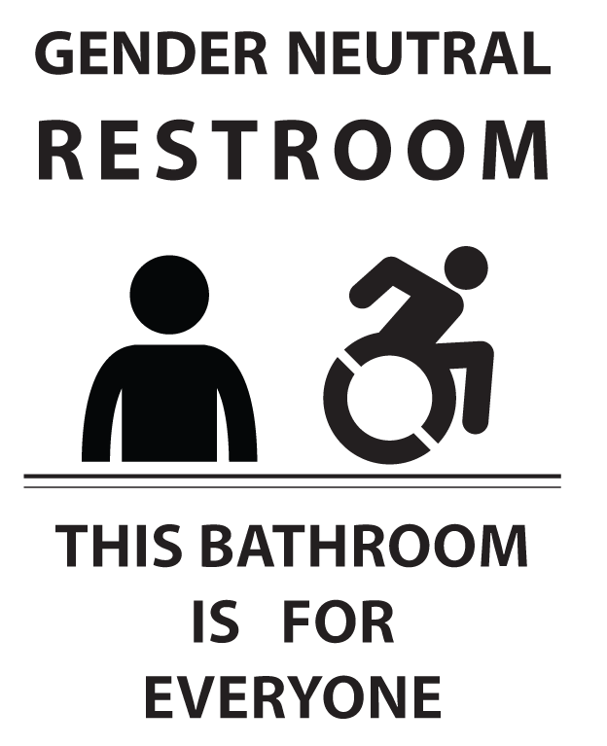

Holiday Experiences of LGBT+ People

To fully understand what a member of the LGBT+ community experiences at holidays is difficult. There are many of us who do not have supportive families. Times when most families get together to celebrate, many LGBT+ people are left alone. Not just the “big holidays,” but every celebration from birthdays, to weddings, to weekend get togethers. Those who have been rejected by the family in which they grew up have no familial connections during these times. Some live hidden lives, afraid to take loved ones to family events; others who are “out” are completely rejected and spend these times alone.
Too often, allies and friends tend to believe, erroneously, that the LGBT+ community automatically takes care of their own. Being LGBT+ doesn’t automatically provide you with a support system, it doesn’t automatically provide an alternate family to provide support and places to go for big events and holidays. Even when members do have good friends, they don’t often think about the realities of living without family support. Birthday parties, holiday parties and the like are fun, but at the end of the day, the LGBT+ person goes home. There are no holiday cards from family members, no phone calls of well wishes, no invites to the next family get together. Oftentimes, people see on Facebook or other social media pictures and conversations of family times of which they are intentionally excluded, sometimes even with private “apologies” from a cousin or brother or aunt, “We would have invited you, but… you understand.” No, we really don’t. We are still that same person we were before we came out, before we decided we had to live true to who we are or let our soul slowly suffocate.
Yes, please include LGBT+ members in your life, your parties, your get togethers. But also understand there are underlying issues you cannot see. While someone might truly appreciate an invite to your giant, family holiday party, if you are the only member there they know, it gets uncomfortable. It can also be a painful reminder of times past, when they were hidden but accepted by their large, happy family. During these times (birthdays, mother’s and father’s days, the big end-of-the-year parties), think about keeping a line of communication open with your friends in the LGBT+ community. If big parties with strangers aren’t their thing, invite them out for coffee, to a movie, just to hang out. Don’t press them into celebrating something just because it’s “that time of year.” Also, before you decide to invite them to your celebration, think carefully about your other family members and their views. They get enough harassment from their own family, they don’t need to listen to your great aunt rail on about how gays are ruining the country, or your cousin talk about how unnatural it is for “a man to want to be a woman,” or how your sister thinks LGBT+ people are unfit to be parents. Conversely, do not ever “out” someone to your family, thinking that will fix the situation. We know. We see the side eye, we feel the distaste emanating from those who disapprove.
Let them know you are open and available to listen if they need to talk. Listen to their hurts, their resentments without taking it personally. Allow them space to be heard, and actually take the time to listen and validate their feelings without excusing their family’s behavior. Keep watch for signs of depression. Let them know they are loved, important, validated and cared for by you. One of the hardest things to do after attending a big “family” event as a guest and not a family member is going home, where there are no cards, phone calls, messages, anything, from their own families. For a lot of us, there just isn’t any “going home” anymore. When we return to our own residence at the end of the day, it feels a lot emptier than when we left.

Large Group Room

Large Group Room

LGBT Ally Workshop Here

LGBT Ally Workshop Here

On Being Misgendered

It’s really sad to be consistently and constantly misgendered. I know that might sound like a whine to folks who haven’t experienced it, especially in light of the number of people in and out of my community who experience far worse. But it’s real.

It’s like being in a dance hall full of thousands of people, and you’re supposed to dance with all of them. But most of them keep stomping on your toes. It hurts but it’s just an annoyance at first. After a while, though, your toes are bruised, and maybe even broken, and people keep doing it. They don’t mean any harm, they’re just clumsy. And you learn all kinds of ways to move and stand and carry yourself that help avoid it a bit. But it still happens a lot, and now your feet are injured so it just hurts more every single time. Pretty soon you stop wanting to dance with a lot of people. Maybe eventually you just stop wanting to dance at all.

~ Kit Malone

Participant Feedback Form

- What is something you liked about the training? Why did you like it?
- What do you wish there were more of?
- What is something you disliked about the training? Why did you dislike it?
- What do you wish there were less of?
- What feedback do you have on the timing of each lesson? For each lesson, please check the column that applies.
Lesson | Was  too short | Was  about right | Was  too long
1. Welcome and Agreement / Covenant
2. Values and Privileges
3. Terminology and Language
4. What LGBT+ Folks Experience
5. Avoiding Unintended Hurt
6. Changing Hearts, Minds & Laws
7. Becoming an Upstander
8. Benefits
9. Personal Action Plan
10. Wrap-Up
Question and Answer Sessions

- Are there any additional topics or information you think should be included? If so, what?
- How much, if any, do you think your future actions will be different as a result of this training? How?
- Do you have any other comments you wish to share? (Optional)

Please turn in your feedback in the matter requested by the facilitators.

Privilege Awareness Exercise
This exercise is anonymous. Do not write your name on this sheet of paper.
For each statement below, circle the one statement that comes closest to how you feel. As is true with all our exercises, if you find this to be too upsetting, you are free to go to another room until the exercise is over.
1. | I am comfortable discussing my significant other at work, including using their name and gender-specific pronoun.
 | Usually true for me. | Often true for me. | Occasionally true for me. | Rarely true for me.
2. | When I’m filling out forms, I question which box to check to indicate my gender.
 | Usually true for me. | Often true for me. | Occasionally true for me. | Rarely true for me.
3. | I dress how I want without being judged.
 | Usually true for me. | Often true for me. | Occasionally true for me. | Rarely true for me.
4. | When I use public restrooms, I fear unpleasant interaction with others.
 | Usually true for me. | Often true for me. | Occasionally true for me. | Rarely true for me.
5. | The media consistently portrays people like me and does so in a positive manner.
 | Usually true for me. | Often true for me. | Occasionally true for me. | Rarely true for me.
6. | I am always comfortable holding my significant other’s hand in public.
 | Usually true for me. | Often true for me. | Occasionally true for me. | Rarely true for me.

Privilege Response Card: Usually True for Me

Usually True for Me

Privilege Response Card: Often True for Me

Often True for Me

Privilege Response Card: Occasionally True for Me

Occa-sionally True for Me

Privilege Response Card: Rarely True for Me

Rarely True for Me

Quiet Room

Quiet Room

Values Clarification Exercise
This exercise is anonymous. Do not write your name on this sheet of paper.
For each statement below, circle the one statement that comes closest to how you feel. As is true with all our exercises, if you find this to be too upsetting, you are free to go to another room until the exercise is over.
1. | If someone is gay, they should appear, speak and act in a way that blends in with the rest of society.
 | I agree a lot. | I agree a little. | I disagree a little. | I disagree a lot.
2. | LGBT neighbors are just as likely to be good neighbors as anyone else.
 | I agree a lot. | I agree a little. | I disagree a little. | I disagree a lot.
3. | Since I have a gay or lesbian friend, it shows that I am not homophobic.
 | I agree a lot. | I agree a little. | I disagree a little. | I disagree a lot.
4. | Everyone should use the restroom that matches their birth certificate.
 | I agree a lot. | I agree a little. | I disagree a little. | I disagree a lot.
5. | Some of my best friends are men, and it is fine if my brother marries one.
 | I agree a lot. | I agree a little. | I disagree a little. | I disagree a lot.
6. | We should stay focused on obtaining gay, lesbian, and bisexual rights now. Transgender rights can come later.
 | I agree a lot. | I agree a little. | I disagree a little. | I disagree a lot.

Values Response Card: I Agree a Lot

I Agree a Lot

Values Response Card: I Agree a Little

I Agree a Little

Values Response Card: I Disagree a Little

I Disagree a Little

Values Response Card: I Disagree a Lot

I Disagree a Lot

(This page is intentionally blank. It is here to assure proper printing in certain circumstances.)

